TASK 2 - LINUX COMMANDS
CHAPTER 1 : SYSTEM INFORMATION COMMANDS
<1>uname
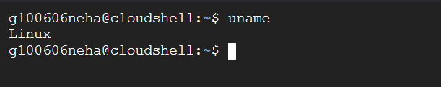
<2>uptime
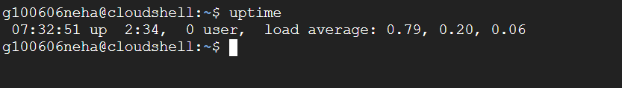
<3>hostname
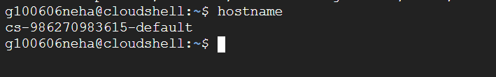
<4>dmesg
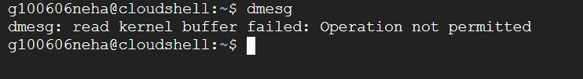
<5>free
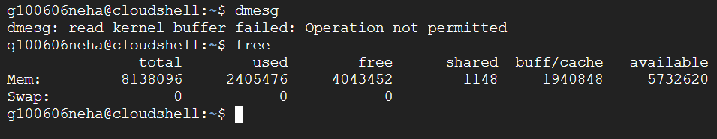

<6>top
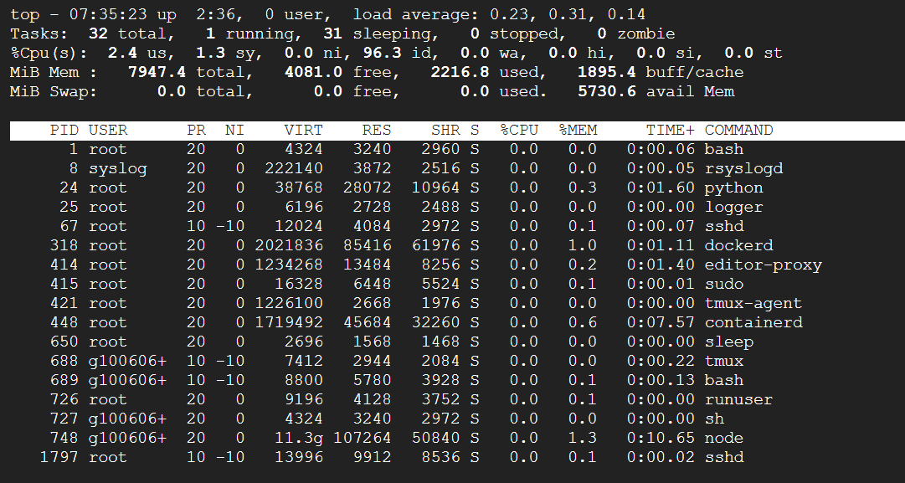
<7>htop
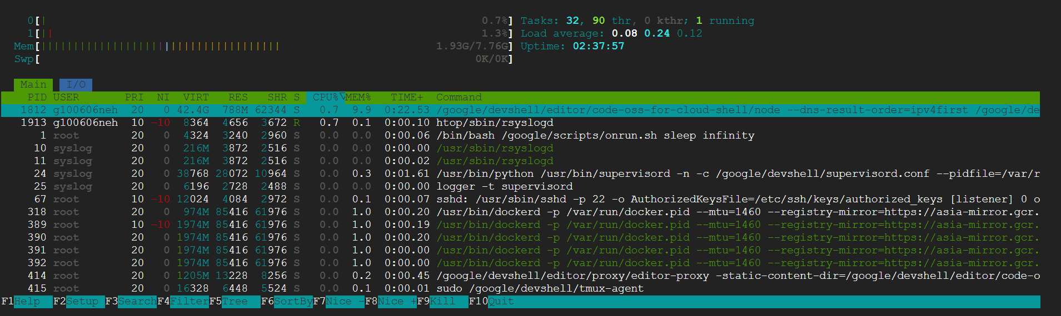
<8>lsb_release
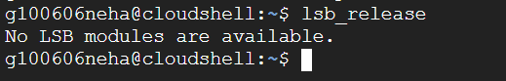
<9>arch
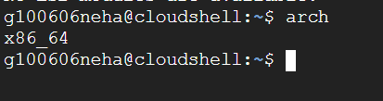

CHAPTER 2 : FILE AND DIRECTORY MANAGEMENT
<1>ls
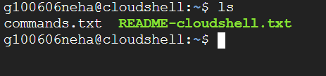
<2>cd
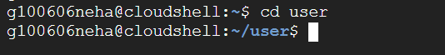
<3>pwd
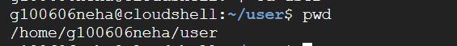
<4>mkdir
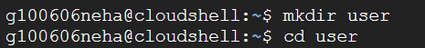
<5>rmdir
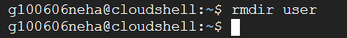
<6>touch
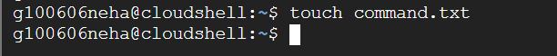
<7>rm
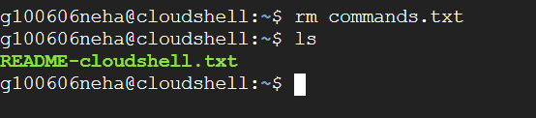

<8>cp
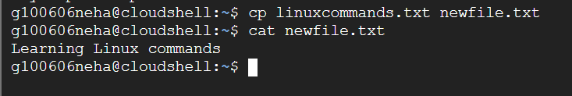
<9>mv
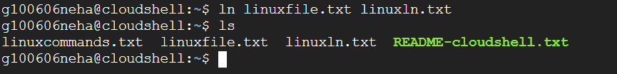
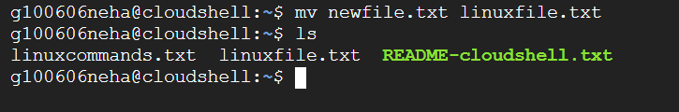<10>ln

|CHAPTER 3 : FILE VIEWING AND EDITING
<1> cat
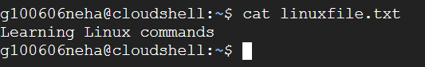
<2> more
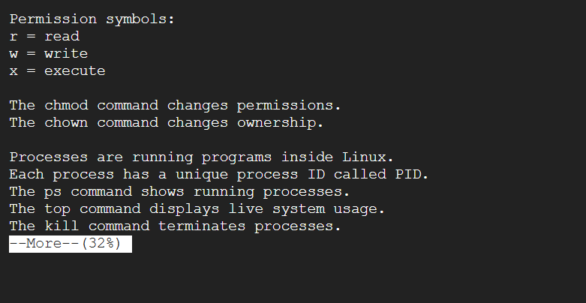
<3> less
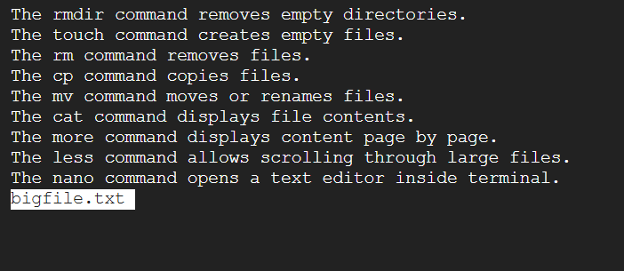

<4> tail
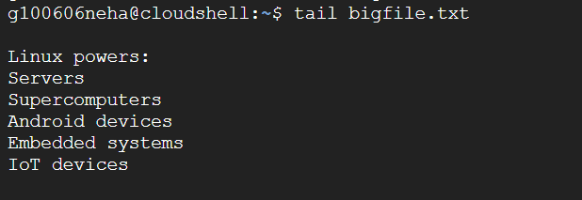
<5> head
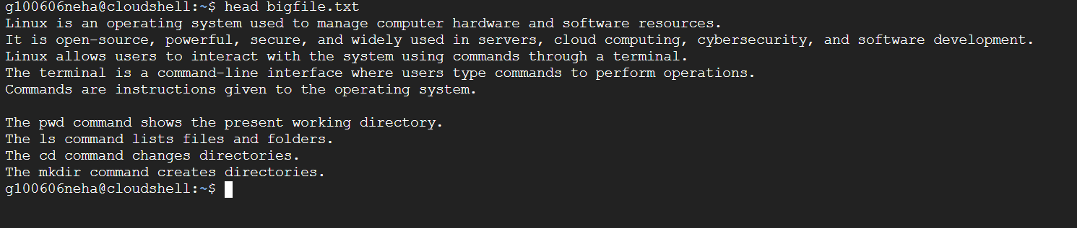
<6> nano
<7> vi/vim

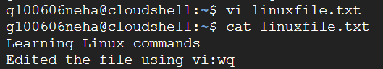

<8> awk
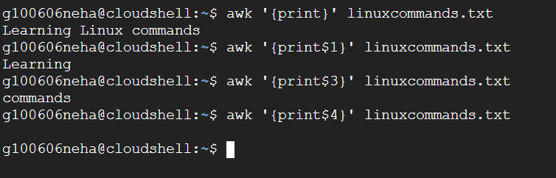

<9>sed
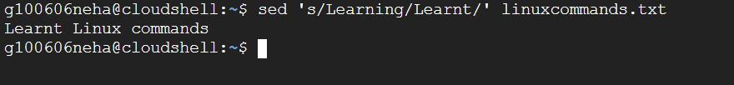

CHAPTER 4 : FILE PERMISSIONS AND OWNERSHIP
<1> chmod
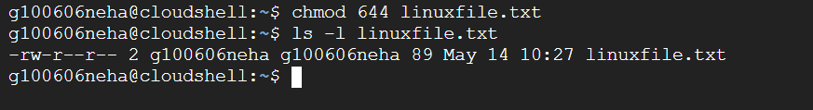
<2> chown
<3> umask
<4> stat
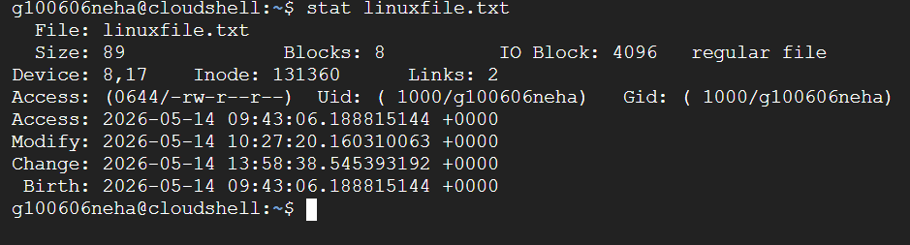
<5>getfacl
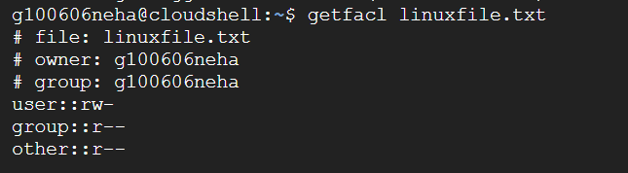
<6>setfacl
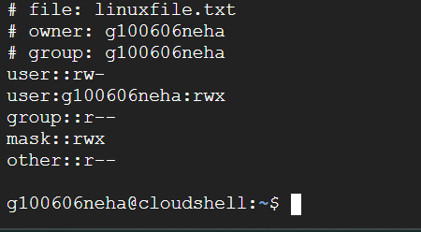

<7>lsattr
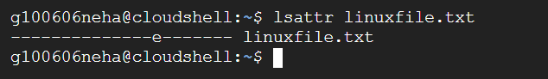
<8>chattr
<9>usermod
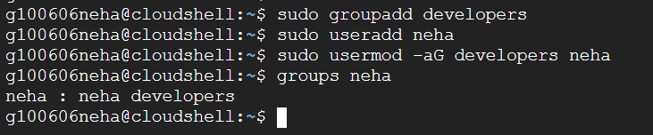

CHAPTER 5 : NETWORKING COMMANDS
<1>ifconfig
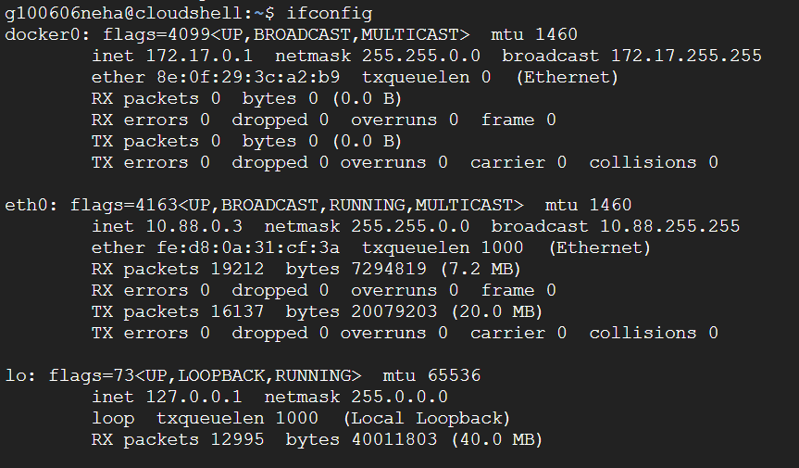
<2>ip
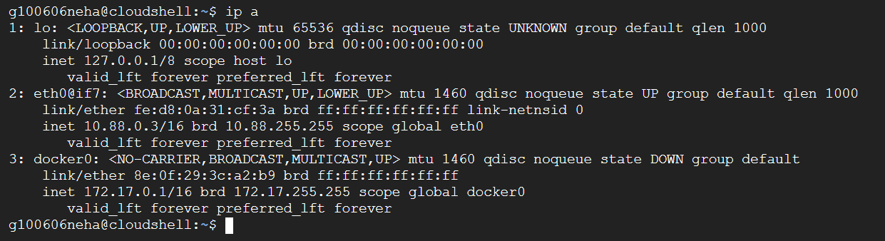
<3>ping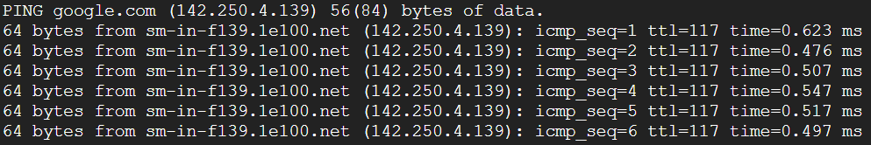
<4>netsat
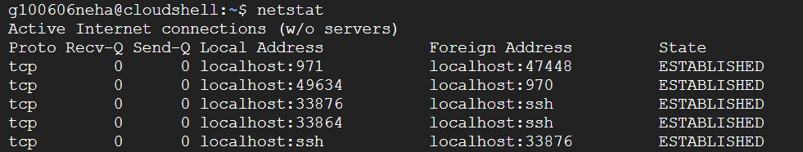
<5>ss
<6>traceroute
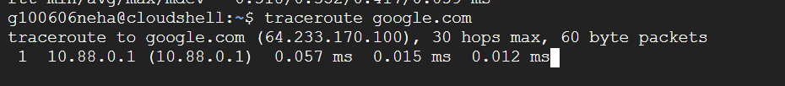
<7>wget
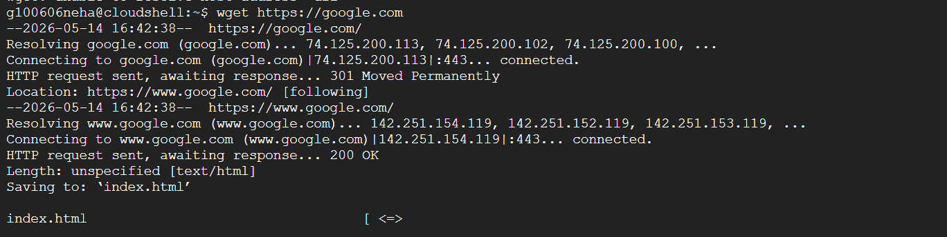
<8>curl
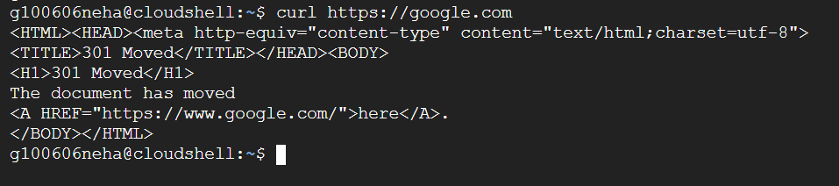
<9>nslookup
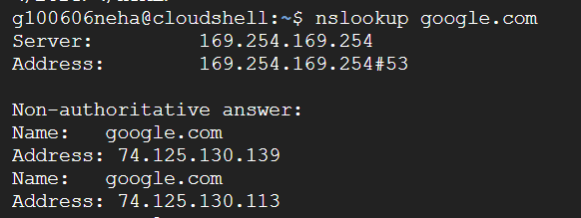

<10>dig
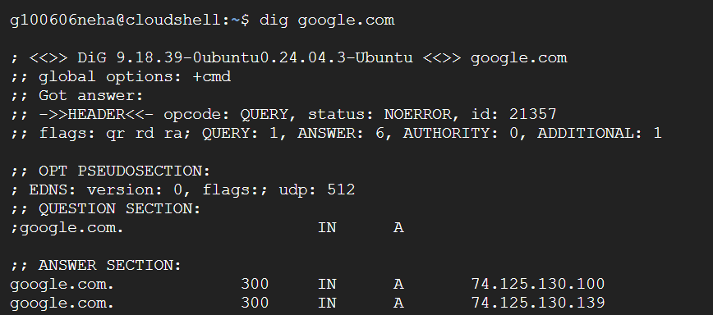

CHAPTER 6 : PROCESS MANAGEMENT
<1>ps
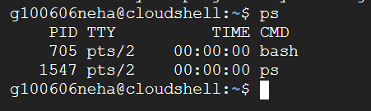
<2>pgrep
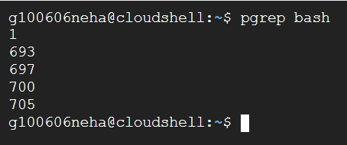
<3>pkill
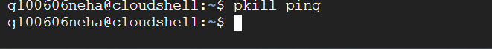
<4>kill
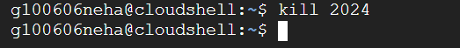
<5>killall
<6>bg
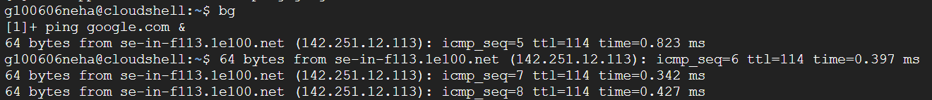

<7>fg
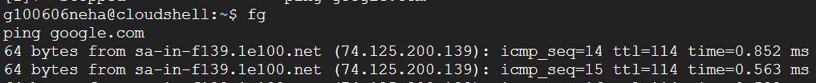
<8>jobs
<9>nice
<10>renics
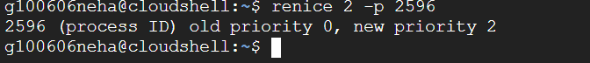

CHAPTER 7 : DISK MANAGEMENT
<1>df
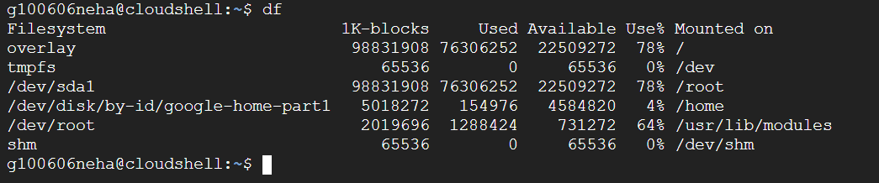
<2>du
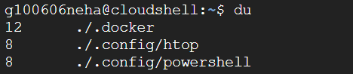
<3>mkfs
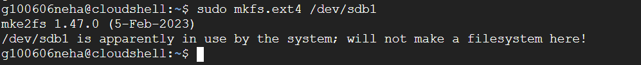
<4>mount
<5>umount
<6>blkid
<7>lsblk
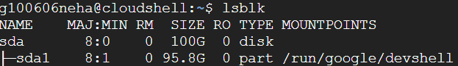
<8>parted
<9>tune2fs
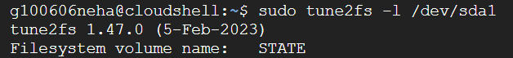

CHAPTER 8 : SYSTEM MONITORING AND PERFORMANCE
<1>top
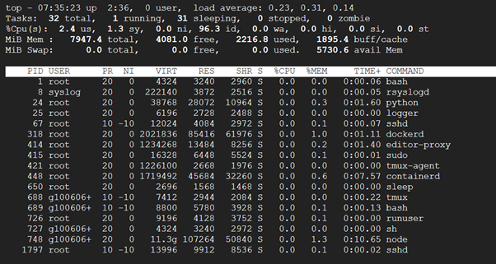
<2>htop
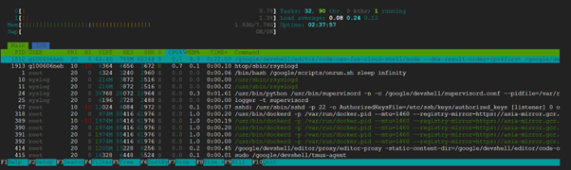
<3>iostat
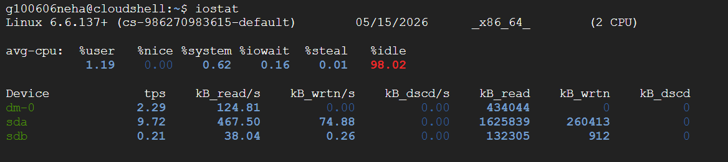
<4>vmstat
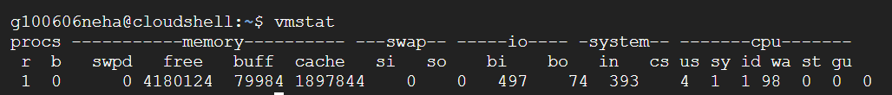
<5>sar
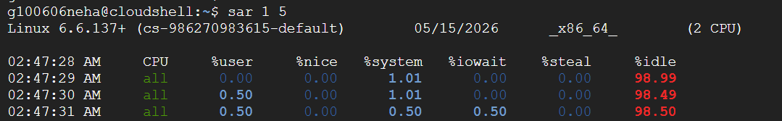
<6>free

<7>mpstat
<8>uptime

<9>dstat
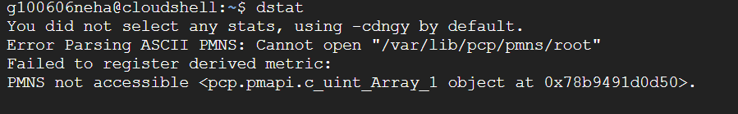
<10>glances

CHAPTER 9 : USER MANAGEMENT
<1>useradd
<2>userdel
<3>usermod

<4>passwd
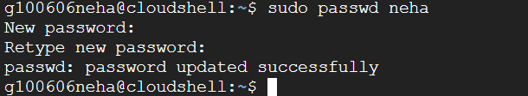
<5>chage
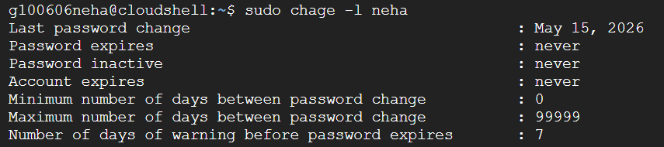
<6>groups
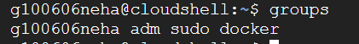
<7>groupadd
<8>groupdel
<9>newgrp
<10>su
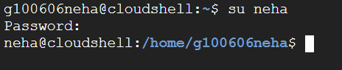

CHAPTER 10 : COMPRESSION AND ARCHIVING
<1>bzip2
<2>bunzip2
<3>xz
<4>unxz
<6>zip
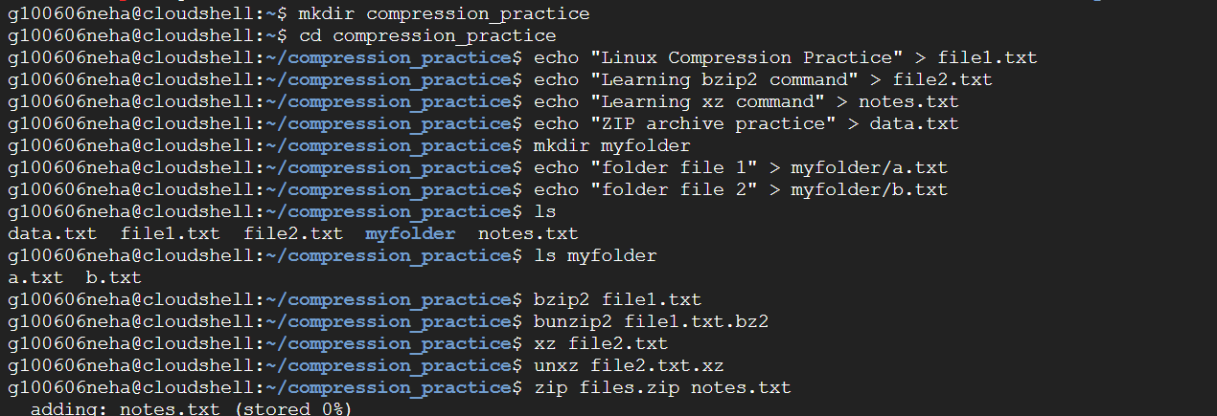
<5>tar
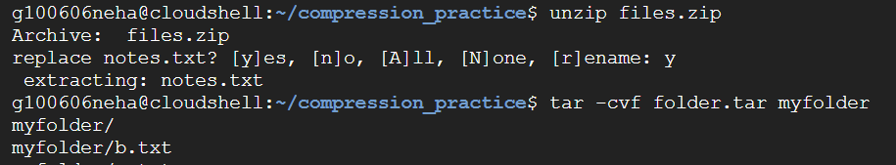
<7>unzip
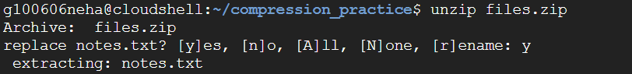
<8>lzma
<9>lzpop
<10>unlzop

